**Part 1: Bug Finding Challenge - API.**

***1.Title*: Bug**

***Severity:* High**

***Test Environment:* Post Request**

[**https://wmxrwq14uc.execute-api.us-east-1.amazonaws.com/Prod/api/employees**](https://wmxrwq14uc.execute-api.us-east-1.amazonaws.com/Prod/api/employees)

***Description:* Post Request . Last Name and First Name accept numbers and symbols.**

***Expected result:* Should accept only the letters.**

***Actual result:* Last Name and First Name accept numbers and symbols.**

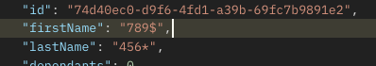

***2. Title:* Bug**

***Severity:* Low**

***Test Environment*: Get Request**

**https://wmxrwq14uc.execute-api.us-east-1.amazonaws.com/Prod/api/employees**

***Description:* Salary and gross should be present in integer numbers.**

***Expected result:* Salary and gross should be present in integer numbers.**



***Actual result:* Salary presented in decimal numbers.**



***3.Title:* Bug**

***Test Environment:* Put Request**

**https://wmxrwq14uc.execute-api.us-east-1.amazonaws.com/Prod/api/employees**

***Severity:* High**

***Description:* In the Put Request salary should be = 52000, gross should be = 2000.**

***Expected result:* Salary should be = 52000, gross should be = 2000.**

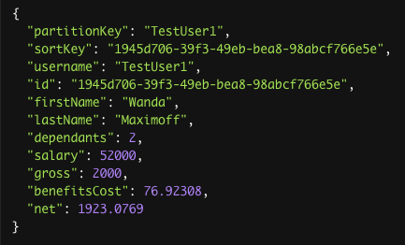

***Actual result:* Salary = 0,0 , gross = 0,0 .**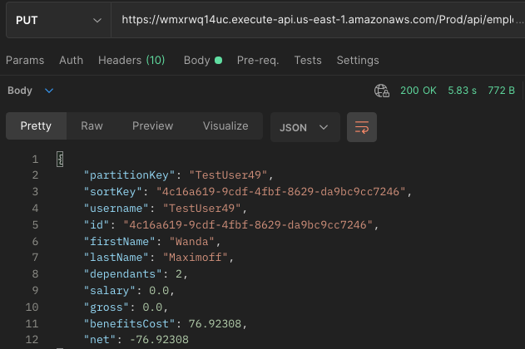

***4.Title:* Bug**

***Severity:* Medium**

***Test Environment:* Delete Request**

**https://wmxrwq14uc.execute-api.us-east-1.amazonaws.com/Prod/api/employees/{{id}}**

***Description:* In the Delete request Response Body should be Plain.**

***Expected result:* Response Body should be Plain.**



***Actual result:*Response Body is 1.**

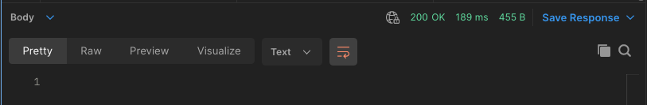

***5. Title:* Bug**

***Severity:* High**

***Test Environment*: Put Request**

**https://wmxrwq14uc.execute-api.us-east-1.amazonaws.com/Prod/api/employees**

***Description:* After sending Put request in the Get Employee List request appears new Employee with updated credentials. Employee which was updated still on the list with previous credentials.**

***Expected result:* On the Employee List only updated Employee should be present.**

**Previous version of Employee should be deleted.**

***Actual result:* On the Employee List previous and updated versions of Employee exist.**





***6. Title:* Bug**

***Severity:* Low**

***Test Environment*: Get, Post, Get, Put Response.**

[**https://wmxrwq14uc.execute-api.us-east-1.amazonaws.com/Prod/api/employees**](https://wmxrwq14uc.execute-api.us-east-1.amazonaws.com/Prod/api/employees)**;**

[**https://wmxrwq14uc.execute-api.us-east-1.amazonaws.com/Prod/api/employees/{{id**](https://wmxrwq14uc.execute-api.us-east-1.amazonaws.com/Prod/api/employees/%7B%7Bid)**}} .**

***Description: Word Dependants .***

***Expected result:* In all types of Response word Dependants should be present in the correct grammar like Dependents.**

***Actual result:* Word Dependants presents in the wrong grammar.**

